Alerting and

Detection

This course describes the foundational ideas behind threat detection and response using Cortex, covering the essential tools and strategies used to understand how to identify and mitigate threats proactively.

Course Objectives
After completing this course, you should be able to:

- Identify the role of indicators of compromise (IOCs) and behavioral indicators of compromise (BIOCs) in threat detection
- Create and manage Correlation Rules
- Describe the capabilities and benefits of using Correlation Rules
- Differentiate between IOCs and BIOCs
- Describe the importance of network security analytics
- Explain how issues are generated
- Describe the features and functionalities of Cortex in enhancing threat detection and response

Lesson Topics
We recommend that you take the lessons in numerical order, but you can use the menu for quick access to any lesson at any time.
Click the lesson title buttons to go to each lesson. You can also navigate the course using the navigation arrows below or the menu bar at the top left of the screen.
Lesson 1: Cortex Threat Detection Strategy
Lesson 2: Cortex Use Cases and Pseudocode
Lesson 3: Cortex Threat Detection Tools
Lesson 4: Cortex Analytics

Cortex Threat

Detection Strategy

This lesson describes why threat detection is an important part of a security strategy and how Cortex can help provide threat protection. Note that in recent versions of Cortex, the terms for alerts and incidents have changed to issues and cases, respectively.

Cortex Threat Protections
As cybersecurity threats consistently evolve and grow in complexity, a powerful threat detection strategy is essential for organizations to safeguard their digital assets. Cortex plays a pivotal role in enhancing an organization's ability to detect and respond to security threats effectively by combining endpoint protection, network security, and advanced threat intelligence. It serves as the cornerstone of a modern threat detection strategy, allowing organizations to proactively identify, investigate, and mitigate a wide range of cybersecurity threats.
Cortex provides protections that help security operations centers (SOCs) align with comprehensive threat detection strategies.


Threat Visibility
Cortex provides organizations with visibility into their network and endpoints, offering real-time insights into potential security incidents. Monitoring and correlating data from across the organization enables the detection of threats at various stages of the attack lifecycle. Cortex not only provides holistic visibility into networks and endpoints, it also covers cloud, software as a service (SaaS) apps, remote systems, and more.


Behavioral Analytics
Cortex employs advanced behavioral analytics and machine-learning models to identify abnormal activities and deviations from normal behavior patterns. This proactive approach is instrumental in detecting emerging threats, zero-day vulnerabilities, and sophisticated attack techniques.


Endpoint Protection
Cortex offers comprehensive endpoint protection, securing a wide range of devices and operating systems. It continuously monitors endpoints for signs of compromise, malicious processes, and suspicious behavior, allowing for rapid threat containment.


Network Security Integration
While Cortex seamlessly integrates with Palo Alto Networks network-security solutions, it also can ingest events, issues, and logs from almost any network device. This provides a unified defense-in-depth approach. It correlates network and endpoint data to detect lateral movement, command-and-control communications, and other indicators of advanced threats.
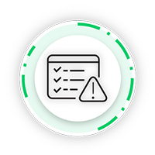

Incident Investigation
In the event of a security incident, Cortex simplifies the investigation process with detailed forensics and threat-hunting capabilities. Security teams can analyze incidents, determine the scope of the threat, and take immediate action to remediate.


Threat Intelligence
Palo Alto Networks continuously feeds Cortex with the latest threat intelligence (TI), ensuring that organizations are equipped to defend against evolving threats. This threat intelligence is derived from global sensors, threat research teams, and industry partnerships. Cortex also integrates and manages threat intelligence from almost any trusted TI source.


Scalability
Cortex is designed to scale with the organization's needs, whether it's a small business or a large enterprise. It adapts to the dynamic nature of modern networks and accommodates growth.
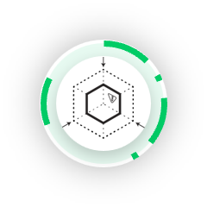

Attack Surface Management
Cortex provides an add-on attack surface management (ASM) with capabilities that provide an attacker’s view of your organization along with asset discovery, vulnerability assessment, and risk management.

Coverage of MITRE ATT&CK Tactics
Cortex covers multiple vulnerability areas that malicious actors might attempt to target.
The following vulnerability areas fit into the MITRE ATT&CK framework. These do not cover the entire MITRE framework.
- 
- Execution
- Attackers, once inside the network, deploy various methods to run malicious code on local or remote endpoints; the Cortex app counters this by detecting malware through network activity analysis, the Pathfinder data collector, Cortex agent data, and the evaluation of suspicious files using WildFire.
- 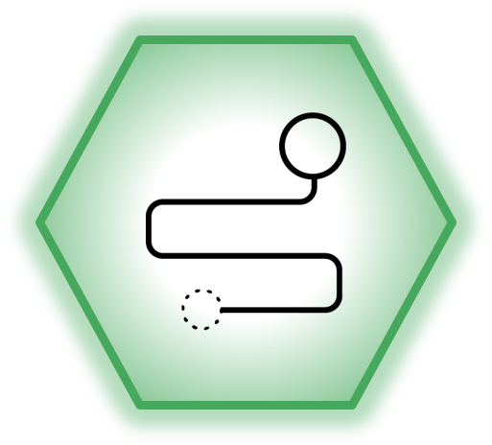
- Persistence
- Attackers aim to maintain network or endpoint access for malicious actions, employing techniques like system restarts or configuration changes; this requires the endpoint to restart a remote access tool or open a back door for the attacker, which the app identifies.
- 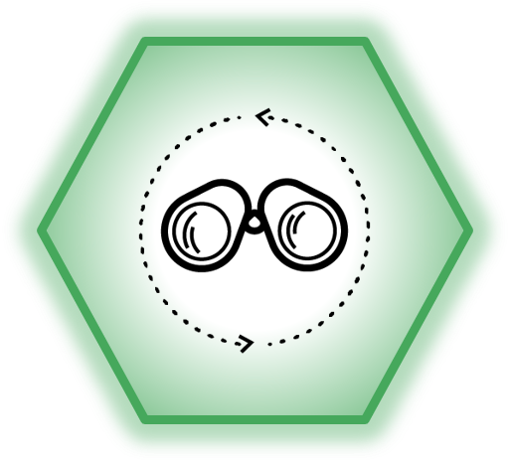
- Discovery
- Attackers with network access use discovery techniques to locate subnets, servers, and services on endpoints, seeking vulnerabilities; the app spots these tactics by monitoring internal network traffic for changes in connectivity patterns and unusual connection rates.
- 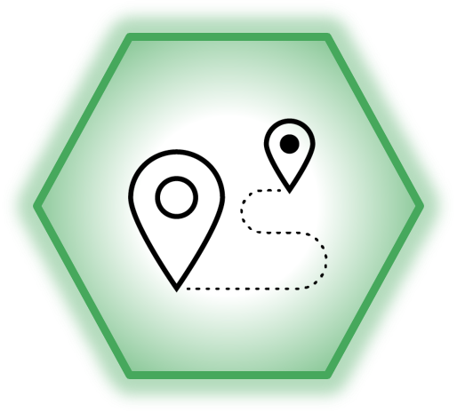
- Lateral Movement
- To expand within a network, attackers use lateral-movement techniques to gain credentials for additional data access, detected by the Analytics Engine through scrutiny of administrative operations, file share access, and unusual user credential usage.
- 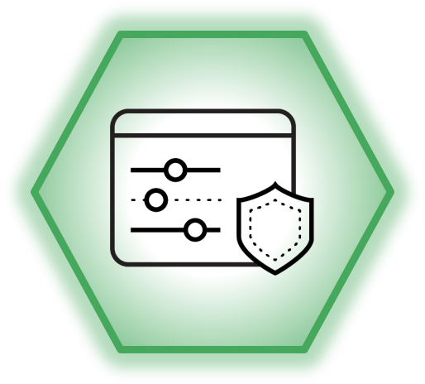
- Command and Control
- Attackers remotely issue commands to endpoints and receive information, which the Analytics Engine identifies by spotting anomalies in outbound connections, Domain Name System (DNS) lookups, and processes with bound ports, detecting changes in connection patterns or unexplained DNS behavior.
- 
- Exfiltration
- Exfiltration tactics involve stealing data from a network, with the app identifying these attacks by monitoring outbound connections, particularly focusing on data transfer volumes, with increases indicating potential data exfiltration.

Detection Rules and Analytics Use Cases
Detection rules can identify specific threat indicators and patterns of malicious activity. They typically consist of a set of conditions that must be met for a potential threat to be identified. For example, a detection rule may trigger an issue if a user attempts to access a sensitive resource outside of business hours.

Detection Rule Use Cases
Click the tabs for more information about detection rule use cases.
Threat Detection
Insider Threat Detection
Compliance Monitoring
Case Response

Issues Versus Cases
To understand alerting and detection in Cortex, it is important to know the difference between issues and cases.

Issues
In Cortex, issues are notifications generated when specific security events or conditions are detected such as potential security threats or anomalies. They serve as early indicators of security issues or unusual activity in your environment, highlighting events that deviate from regular behavior. When an issue is triggered, it can initiate an investigation process, with security analysts tasked to assess its significance and determine whether it signifies a genuine security threat or is an informational event. Issues can have various statuses (e.g., open, acknowledged, or resolved), allowing for tracking of the investigation's progress.
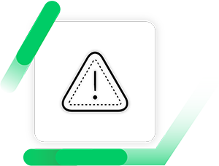

Cases
Cases can be seen as a higher-level classification of security events. These cases often encompass multiple related issues and address more extensive security issues. Their primary function is to group and coordinate related issues or events that together constitute a significant security breach or problem. Cases represent broader and more complex security challenges, necessitating a coordinated and structured response. When a collection of related issues forms a case in Cortex, it triggers a more comprehensive response strategy that may include containment and eradication efforts. A well-defined case response plan guides actions in this context, and cases may also have various statuses (e.g., open, active, resolved) to monitor and manage the case response process effectively.
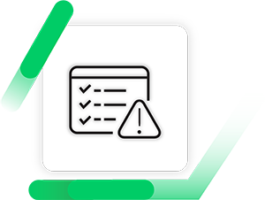

Similarities and Differences
While issues and cases have some similarities, the differences within Cortex are notable. Click the tabs to compare issues and cases.
Similarities
Differences
- In terms of scope, issues represent individual security events or conditions, whereas cases aggregate multiple related issues to address more extensive and complex security challenges.
- The response intensity varies; issues in Cortex often involve validating the issues themselves, whereas cases demand a comprehensive and structured response that may require the coordination of multiple teams and a range of actions.
- Cortex's documentation for cases is more detailed, covering aspects such as the breach's origin, impact assessment, containment strategies, recovery plans, and lessons learned.
- Cortex's may offer aggregation functionality, enabling the grouping of multiple related issues into cases when they indicate a shared security issue.

Cortex Use Cases

and Pseudocode

This lesson describes what use cases are and how they can be applied in determining how to enable Cortex effectively. It also covers pseudocode and how it is used in Cortex.

What Is a Use Case?
A use case can be anything that adds security value, starting with prevention as the most important goal and ending with telemetry data that provides insight. When we talk about traditional security information and event management (SIEM), that technology is designed to alert when the policies, guidelines, or security controls are circumvented, allowing a potential attack to happen. The use case is the description of what it is that the SIEM should be alerting on.
Use cases can be specific or at a higher level. For example:

​​​​High Level

Protecting against insider threat.

Specific

Alerting when a user moves large amounts of data outside of the company.
High-level use cases are often used to better understand what specific areas of insider threat you should be most concerned about. It could also help understand what an insider threat might look like. This could then be broken down into multiple lower-level use cases and even associating several rules with that high-level use case. Often, the higher level use cases are more of a business case and need to be better understood and defined.

Why Is a Use Case Important for Traditional SIEM?
A use case is important for traditional SIEM for the following reasons.

Defining

They ultimately define what the SIEM is trying to protect and alert against.

Customization

Security teams can customize their SIEM to protect against what they perceive to be their biggest threats, using use cases as a way of defining those.

Simplicity

It allows security teams to explain complex matters in a simple way that all stakeholders can understand, regardless of their technical capabilities.

Things to Consider
Click the arrows to learn more about what to consider when working with use cases.
- Make Sure They Are Well-Defined
Poorly-defined use cases can lead to a lot of confusion and time wasted getting additional clarification. Time can also be wasted then when it comes to rule creation as the rules may not reflect the desired outcome.
- Multiple Rules
Sometimes the best way to achieve a use case is with multiple rules, rather than one super complex one. This allows for easier updates to be made in the future.
- Use Case Library Is Essential
Often you will have similar use cases and sharing these out in a library will save time for yourself and others. You may only need to tweak a use case and its associated rules, rather than starting from scratch.
- Check That You Have the Correct Sources and Logs
When drafting a use case or talking around rules, you need to make sure that you are using the relevant technologies and that those technologies provide the correct level of logging. Often the best way to do this is to investigate and generate a list of all log sources or have a validation stage to consider the possibilities of what you are trying to achieve.
- Make Sure It Is Easily Understood
Running use case workshops and whiteboarding ideas works well for this. Having all the relevant staff in one room and discussing ideas and desired outcomes helps. When drafting the associated rules for a use case, it is a good idea to use pseudocode so that the rules can be easily understood by all parties involved.

I Have a Use Case, What's Next?
It doesn’t matter where the use case comes from. Rules need to be created to start protecting against that use case. Those use cases are the foundation for subsequent work, whether high level like “insider threat” or specific scenarios, such as “we want to check if anyone outside human resources (HR) accesses finance systems.”
When looking at the required rules, you look at what technology you have and what the use case is. From there, you can sketch out what is possible to alert and how you can achieve the desired use case. You then need to draft that rule into something usable and understandable by all stakeholders and technical staff. For this, you can look to employ the use of pseudocode.

What Is Pseudocode?
Pseudocode is a high-level, informal programming language or notation used by programmers and software developers to plan and outline algorithms or program logic. It is not meant to be executed by a computer; it serves as a way to express the logic of a program in a more human-readable and structured form before actually writing the code in a specific programming language.
Pseudocode uses plain language mixed with some programming constructs to describe the steps and operations a program needs to perform. It is particularly useful during the initial stages of program design and helps programmers think through their logic and design without getting bogged down in the syntax details of a particular programming language.
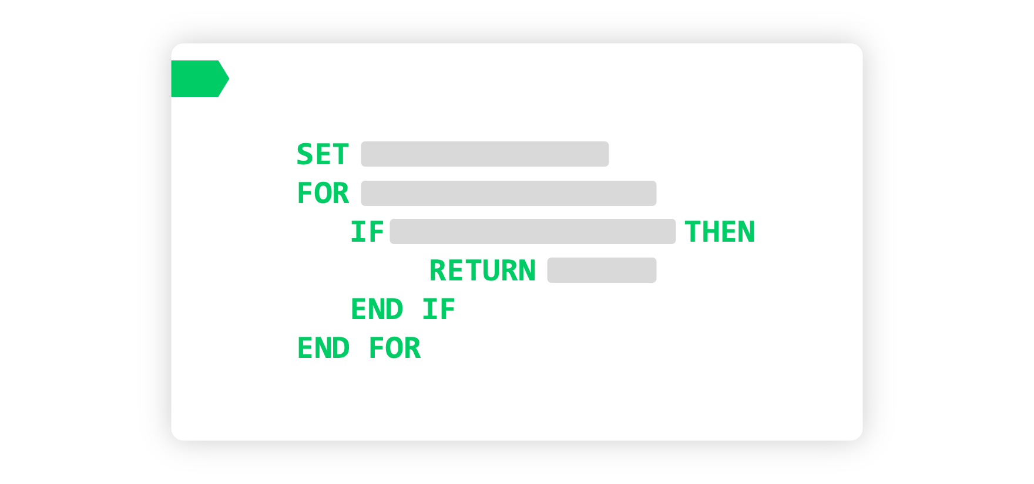

How Pseudocode Is Used in Cortex
Creating effective rules to safeguard against identified use cases is an essential aspect of protecting digital assets. These use cases can originate from various sources. Irrespective of their origins or the depth of their specifics, these use cases provide the foundation upon which the subsequent work hinges. But where does one begin when crafting rules to protect against these defined use cases? The key is to articulate high-level steps for what needs monitoring and protection and to do so in a manner that is readily comprehensible by all stakeholders, from non-technical personnel to seasoned experts. This is where pseudocode becomes an invaluable tool.

Coding a Rule Using Pseudocode
Click the arrows for more information about how to code a rule using pseudocode.
- Step 1: Define the Purpose
Clearly state the purpose of the rule. What problem or task does this rule address? Understanding the rule's goal is essential before proceeding with pseudocode.
- Step 2: Identify Inputs and Outputs
Determine what inputs the rule requires and what outputs it should produce. This could include variables, data, or user interactions.
- Step 3: Outline the Control Flow
Describe the flow of control within the rule. Use common programming constructs like loops, conditionals, and function calls to structure the logic. Pseudocode is less concerned with syntax and more with conveying the algorithm's structure.
- Step 4: Specify Conditions
Define the conditions that trigger or affect the rule. Use if statements, while loops, or other conditional constructs to express when certain actions should occur.
- Step 5: Use Plain Language
Write the pseudocode in plain language, keeping it as simple and understandable as possible. Avoid getting bogged down in syntax details or programming language-specific conventions.
- Step 6: Add Comments
Include comments or annotations to clarify the logic or provide additional context where needed. Comments can make your pseudocode more understandable to others and your future self.
- Step 7: Test and Validate
Review your pseudocode to ensure it accurately represents the rule's behavior. Imagine running through the pseudocode step by step to see if it achieves the desired outcome.

What Is XQL?
Cortex Query Language (XQL) is a query language for querying data ingested into Cortex. It's used for investigating and analyzing network and endpoint security events. XQL forms queries in stages, where each stage performs a specific query operation, and stages are separated by a pipe character (|). XQL can be used to query data from the Cortex Data Model (XDM) or specific datasets.

When Is XQL Used?
XQL is primarily used in the context of security analytics and investigation. It's employed for analyzing security events and logs to detect and investigate potential security threats. It can be used for a wide range of tasks, including threat hunting, case response, and forensic analysis. XQL is used when there is a need to query and analyze large volumes of security-related data for potential security cases.
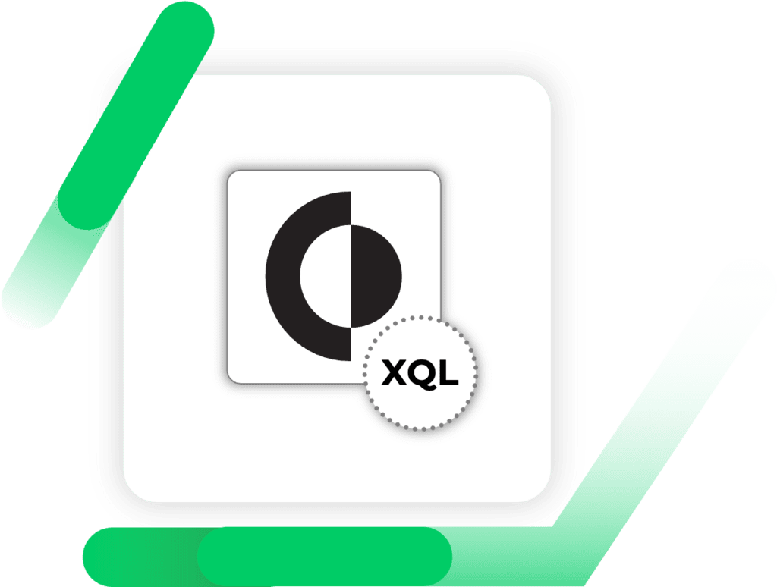

How is XQL Used?
XQL queries are created in the Query Builder within Cortex, allowing security analysts to interactively construct and run queries. Queries can be used to search data within the XDM or specific datasets, depending on the specific use case. XQL queries can include various components such as data filters, field selection, data transformation, and aggregation. The XQL query interface provides suggestions, auto-suggestions, and features like saving and sharing queries for collaboration.

Components of XQL
Click the tabs for more information about the components of XQL.
Stages
Functions
Operators
XQL queries can use operators usually to relate some data (variables and/or values). XQL operators are comparison operators, Boolean operators, array and range operators, and a tagging operator. For example, "in" in the example below is a range operator that returns a Boolean value.
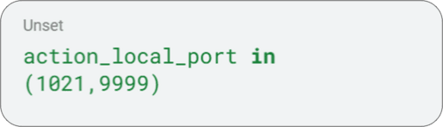

XQL Language Features
XQL is a query language that allows you to query for information contained in a wide variety of data sources. Out of the box, you can query against raw Cortex XDR logs using the xdr_data dataset. You can also ingest data from third-parties and then query against those datasets as well.
XQL is similar to other query languages, and it uses some of the same functions as can be found in many structures query language (SQL) implementations, but it is not SQL. XQL forms queries based on stages. Each stage performs a specific query operation. Stages are delimited by pipes (|). XQL supports:
- Simple queries
- Joins and Unions
- Aggregations
- Filters that identify a subset of records to return in the result set
- Queries against standard datasets
- Queries against custom-imported datasets
- Queries against presets, which are collections of information that are specific to a given type of network or endpoint activity such as authentication or file transfers

Useful XQL Commands
When working with XQL, you will begin to develop your own set of useful commands such as the alter command that allows users to create their own fields in queries. Another useful option is using the same command multiple times using commas. For example: |alter X="example one", B="example two". This example demonstrates multiple uses of alter under the same stage and within the same command usage, separated by a comma.

Accessing the XQL Development Environment
You can access the XQL development environment in the management console in different ways.
- 
- From the Query Builder
- To access the XQL development page from the Query Builder, go to Investigation & Response > Query Builder.
- 
- From the Query Center
- To access the XQL development page from the Query Center, go to Query Center and then click the +New XQL Query button.
- 
- Using the Browser
- To access the development page from the browser, type /xql after the base URL in the address bar.
- 
- Using the Quick Launcher
- To access the XQL development page from the Quick Launcher, click the Quick Launcher, type /XQL, press Enter, and click the path that pops up.

XQL Search Page Basics
Click the arrows to learn more about how to manage your XQL queries. Click the images to enlarge them.

XQL Editor
- The XQL query editor is in the top pane where you can write your XQL queries. The query editor provides features to color code and autocomplete the XQL code. It also shows syntax errors as you type.
- 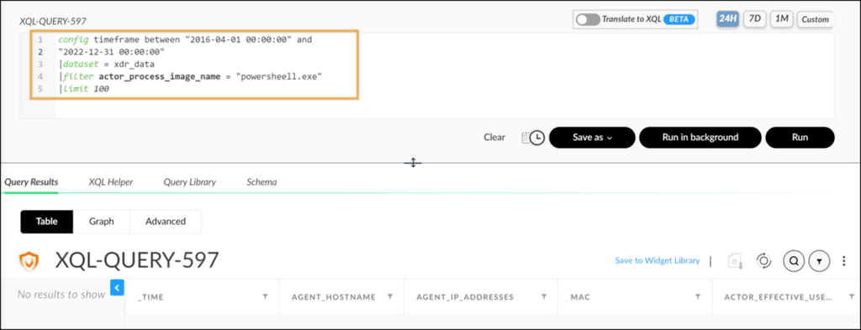

Search Period Specification
- In XQL, “search period specifications” refer to the time frame or period for which you want to query or search for data within the Cortex platform. These specifications allow you to narrow down your search to specific time intervals. This is crucial in security analytics and investigation because you often need to examine events or data within a particular timeframe to identify and respond to security threats.
- 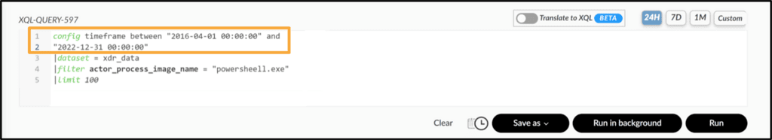

XQL Query Options
- There are different options to run your query, including Run, Run in background, and Save as. The Run button executes the query in the foreground, which means you cannot work with the browser until a result set is generated. You can also run your query later at a specific time. Save as -> Correlation Rule is also a convenient way to save queries as correlation rules.
- 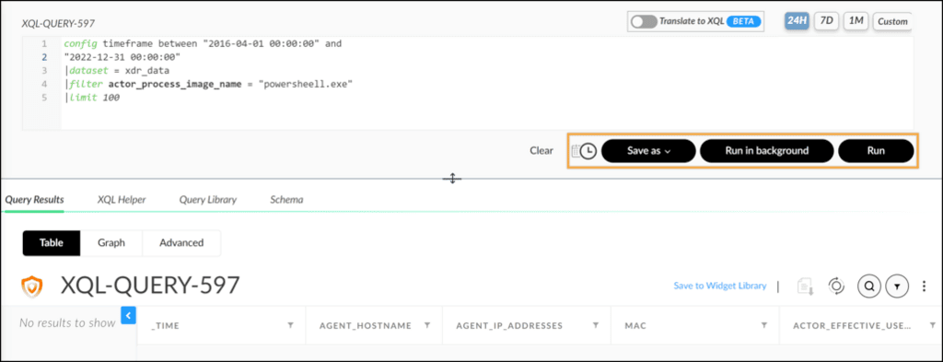

XQL Helper

- XQL Helper provides XQL meanings and syntax.
- 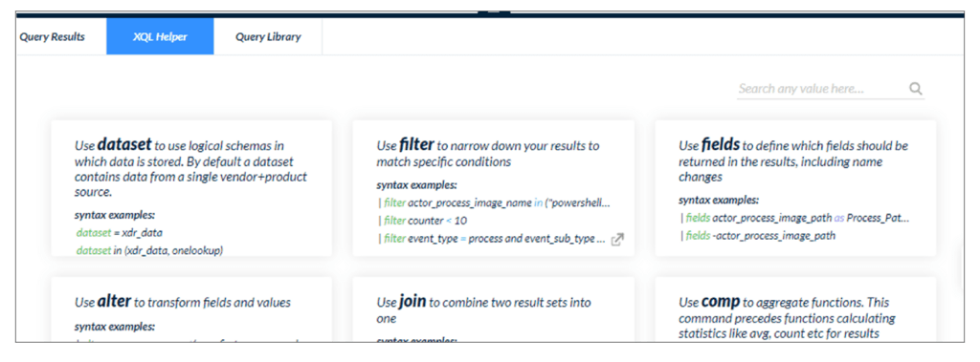

XQL Query Results

- XQL Query Results allows you to switch between table and graph. Additionally, you can use Export to file to save the result to a file.
- 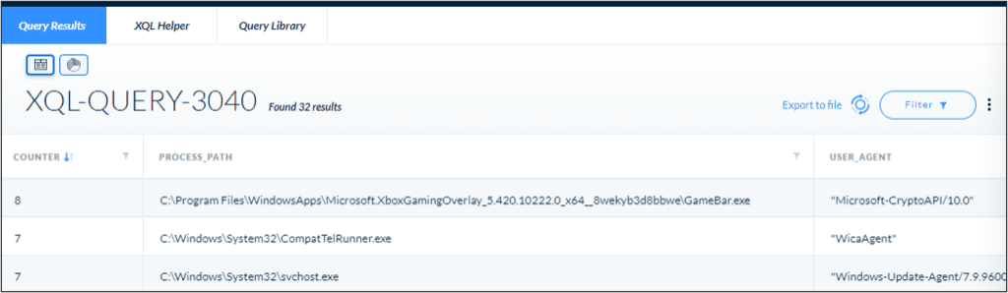

XQL Library

- XQL Library allows you to see pre-defined queries.
- 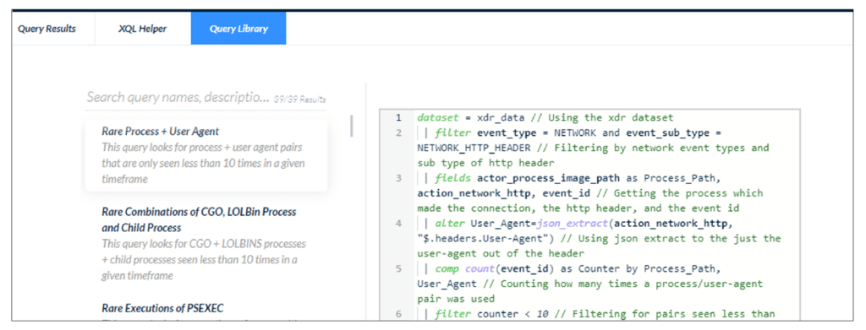

Cortex Threat

Detection Tools

This lesson describes the differences between indicators of compromise (IOCs) and behavioral indicators of compromise (BIOCs). This lesson also describes how Correlation Rules can improve threat detection analysis and the key considerations involved when creating and managing these rules.

IOCs, BIOCs, and Correlation Rules
In the world of cybersecurity, detecting and mitigating threats is a top priority for organizations. IOCs, BIOCs, and Correlation Rules are three powerful rules that play a crucial role in threat detection and response. By understanding each detection rule's unique strengths and applications, security professionals can effectively defend against attacks and safeguard their organizations with the power of analytics.
The following tools are part of the broader field of analytics, where data-driven insights and intelligent algorithms are leveraged to enhance security.


IOCs are specific artifacts or patterns associated with threats and serve as fundamental building blocks for threat detection.


BIOCs delve deeper by focusing on identifying behavioral indicators of compromise, adding a layer of context to threat identification. Both IOCs and BIOCs are key components of analytics-driven cybersecurity strategies.


Correlation Rules provide a more advanced and contextualized approach to threat detection by analyzing correlations among multiple events. They harness the power of analytics to identify complex attack patterns and suspicious behaviors that may go unnoticed when examining individual data points. The integration of analytics into Correlation Rules enables organizations to uncover sophisticated threats that require a holistic view of their cybersecurity landscape.

What Are IOCs?
An IOC is a piece of information or a pattern that indicates the presence or potential presence of malicious activity within a system or network. It is used in cybersecurity to detect and identify threats, allowing security professionals to respond and mitigate the impact of an attack. IOCs can be generated based on various sources, including threat intelligence feeds, security research, and internal analysis.

IOC Purpose
The primary purpose of an IOC is to serve as a signature or a "fingerprint" of malicious behavior. It helps security systems and tools to recognize and alert on the presence of known threats or suspicious activity. IOCs can be specific to certain malware strains, attack techniques, network behaviors, or other malicious indicators.

IOC Benefits
By leveraging specific artifacts such as file hashes, IP addresses, domain names, and system indicators, IOCs enable security systems to recognize the presence of malicious behavior and generate issues for prompt response and mitigation. IOCs serve as digital fingerprints of threats, allowing security professionals to proactively defend against attacks and protect their organizations.
Click the tabs for more information about what IOCs can detect.
Malware Hashes
IP Addresses
Domain Names
File Names or Paths
Registry Keys or System Artifacts

IOC Rules
Cortex IOC rules are intended to detect known, simple malware.

Creating an IOC Rule
From the management console, navigate to Detection Rules > IOC to create and manage IOC rules. To create an IOC rule, click the +Add IOC button in the top right. To manage a rule, use its context (right-click) menu. The quickest way to create multiple IOC rules is to import IOCs from other reliable threat intelligence sources into your Cortex XDR instance. Palo Alto Networks does not provide IOC rules, although it does provide global BIOC rules.

Click the image to enlarge it.
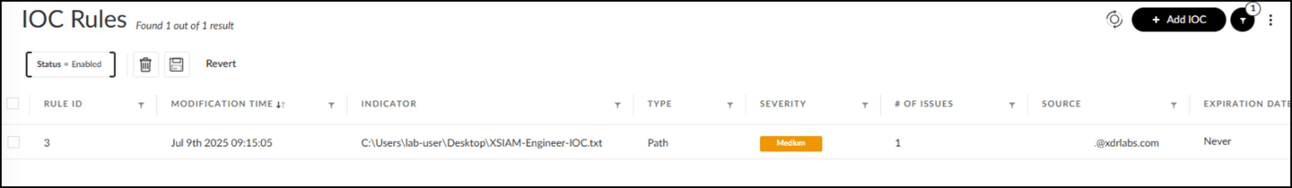

Managing IOC Rules
Open the context menu of an IOC rule to take actions including Edit, Disable, and Delete. The key attributes of IOC rules are as follows.

Indicator

Indicator is the value of the indicator, such as a file name, an IP address, or a hash value.

Type

Type is the category of the threat indicator such as Full Path, File Name, Domain, and Hash.

Expiration Date

Expiration Date is the date and time at which the IOC will automatically be removed from the Cortex instance.

Reputation

Reputation is the level of the IOC rule’s reliability, such as Completely Reliable and Unreliable.
Note: A Cortex IOC rule does not have a name attribute. The indicator value in the indicator field ensures the uniqueness in the IOC table. In other words, you cannot add two IOC rules with the same Indicator value such as the same IP address.

What Are BIOCs?
BIOC rules are designed to identify behavioral indicators of compromise, which encompass various tactics, techniques, and procedures employed by potential threats. By understanding the various types of behavior that BIOC rules can detect, you can effectively configure rules that align with your organization's security objectives. This knowledge enables you to proactively identify and respond to potential threats based on their observable behaviors, rather than relying solely on traditional indicators of compromise like hashes or signatures.
Click the tabs for more information about the types of behavior that BIOC rules can detect.
Processes
Registry
Files
Network Activity
An example of BIOC rules is shown here.
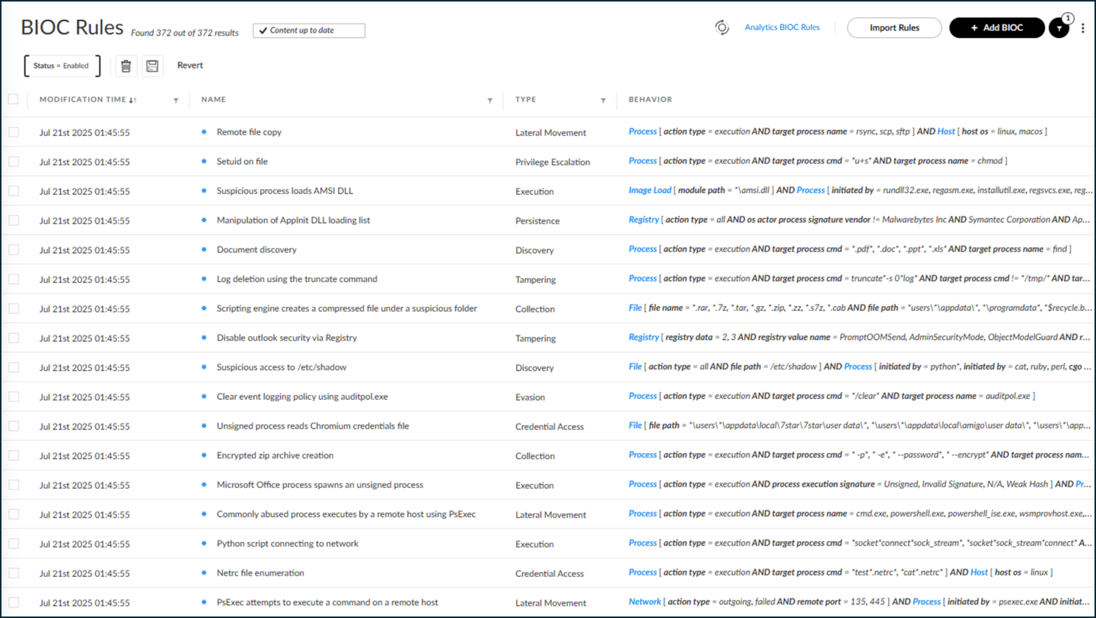

Key BIOC Attributes
BIOC rules have specific attributes that allow you to understand key threat details like the type of attack, its behavior, and its severity.
The key BIOC rule attributes are as follows.
Attribute | Description
Global Rule ID | A globally unique identification number for the rule. If a rule is not of type Global BIOC rule, this attribute is empty.
Name | A unique name that describes the rule.
Type | The category of the attack event, which is typically the stage in the attack lifecycle. This could include dropper, evasion, lateral movement, or tampering.
Behavior | The search condition to extract this issue from the data stream.
Severity | The severity level of the issues created based on the rule definition.
# of Issues | The number of matches triggered by this rule.
Source | The user who created this BIOC, the name of a file from which it was created, or Palo Alto Networks if it is a global rule.
MITRE ATT&CK Tactic | The type of MITRE ATT&CK tactic that this BIOC rule prevented.

How Are IOCs and BIOCs Different?
IOCs and BIOCs both detect threats, but they differ in terms of the information they represent and how they are used.
While IOCs are specific artifacts or patterns associated with known threats, BIOCs focus on the behavior or actions of attackers. BIOCs involve monitoring activities such as lateral movement, privilege escalation, anomalous network traffic, or unusual user behavior.
IOCs are valuable for quickly detecting known threats based on their unique characteristics, whereas BIOCs provide a more dynamic and behavior-focused approach to identifying malicious activities that may not have a fixed signature. Both IOCs and BIOCs play important roles in a comprehensive cybersecurity strategy, complementing each other to enhance threat detection and response capabilities.
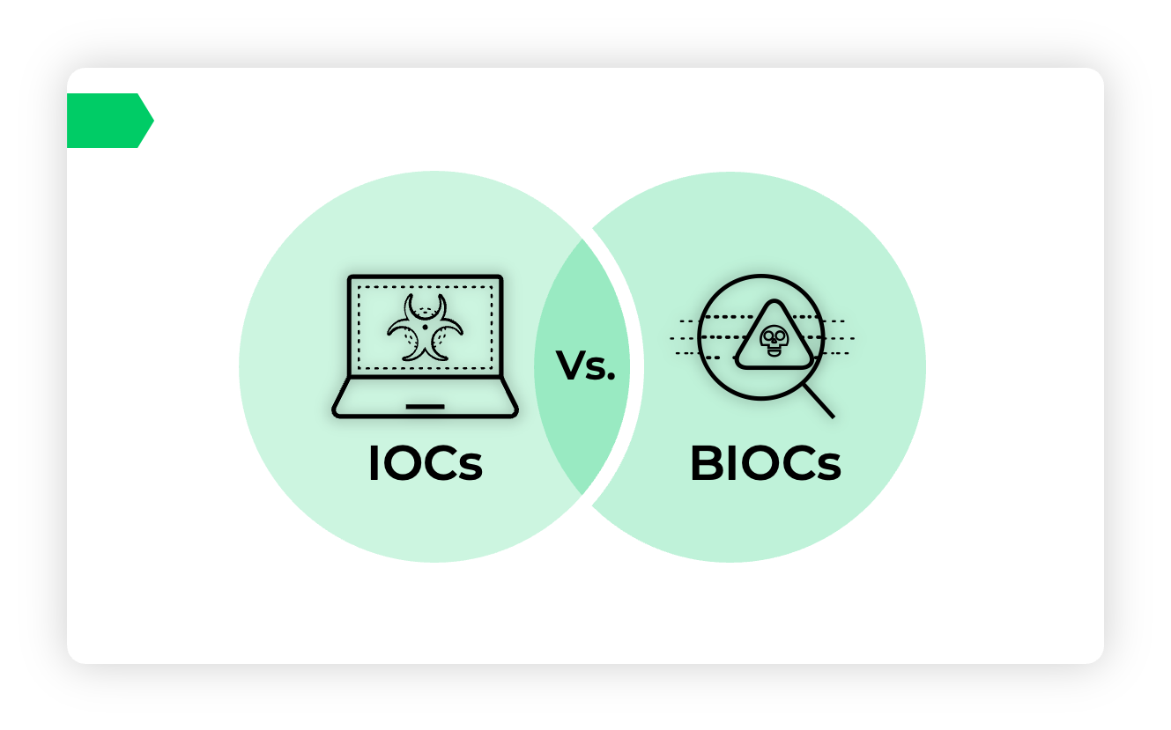

​What Are Correlation Rules?​
Correlation Rules in Cortex help you analyze correlations of multi-events from multiple sources using the XQL-based engine. They allow you to create scheduled rules and trigger issues based on these rules within a defined time frame and schedule. Correlation Rules can be managed and analyzed on the Correlation Rules, Issues, and Cases pages. These rules are also factored into the case count displayed on the dashboard.

Correlation Rules Benefits
Correlation Rules provide a more advanced and contextualized approach to threat detection and analysis by analyzing multi-event correlations, leveraging a powerful query language, enabling scheduled rule execution, and offering options for issue suppression and MITRE ATT&CK mapping. These capabilities enhance the efficiency and effectiveness of security operations by providing a holistic view of potential threats and enabling proactive responses.


​​Correlation Rules Table​​
The Correlation Rules table provides various details for each rule such as the number of issues triggered, issue categories, datasets, descriptions, drill-down queries, failure reasons, insertion and modification dates, last execution times, MITRE ATT&CK tactics and techniques, severity levels, rule IDs, schedules, suppression settings, and more.
Click the image to enlarge it.
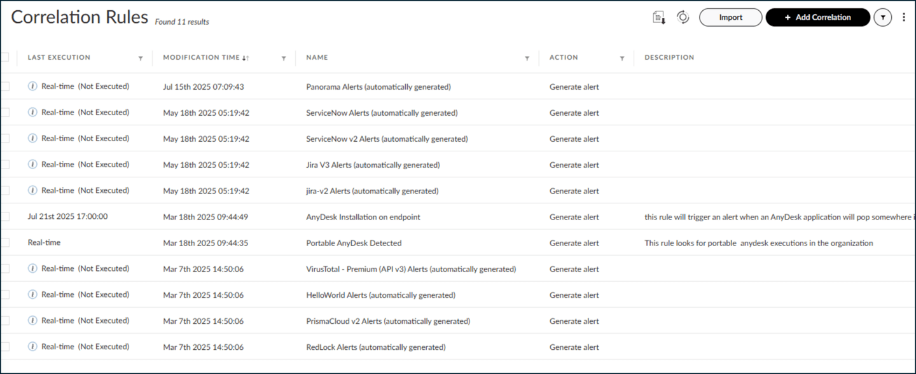

Correlation Rules Differentiated Approach
Correlation Rules provide a differentiated approach compared to traditional IOCs in the context of threat detection and analysis.
Click the arrows to view more information on the differentiation of Correlation Rules. Click the images to enlarge them.

Multi-Event Analysis
- Correlation Rules enable the analysis of correlations among multiple events from various sources. Instead of focusing on individual IOCs, Correlation Rules allow you to identify patterns and relationships between events, providing a more comprehensive understanding of potential threats.
- 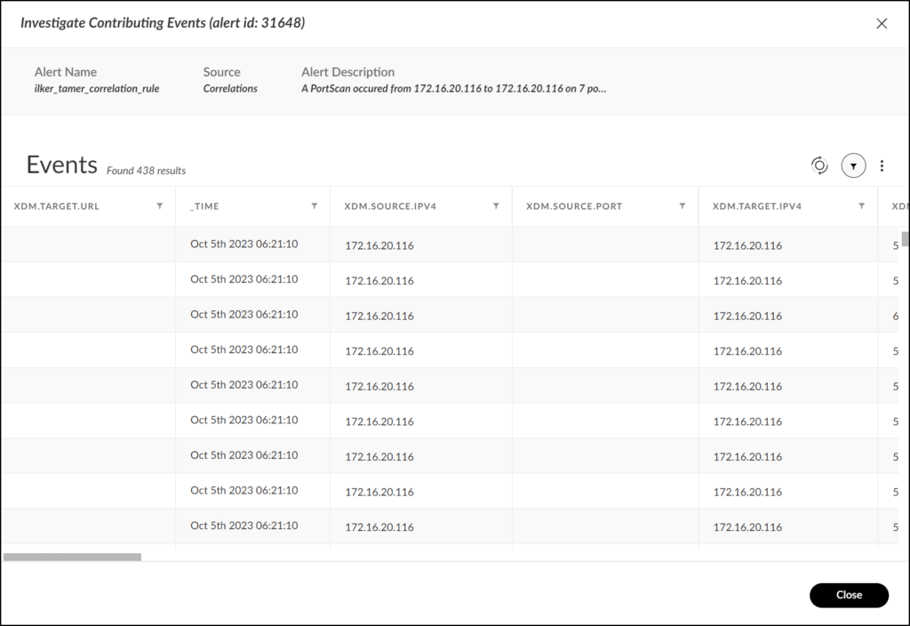

Learning the XQL Engine in Correlation Rules
- Correlation Rules utilize the XQL engine for creating scheduled rules. XQL is a powerful language that allows you to construct complex queries and perform advanced searches across your security data. It provides flexibility and granularity in defining the conditions and parameters for correlation.
- 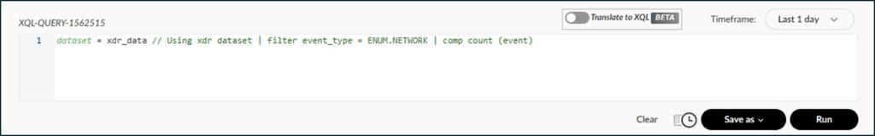

Real-Time Versus Scheduled Rules
- There are two options when it comes to rule schedules: Real-Time and Scheduled. The key distinction between real-time and scheduled rules is that real-time Correlation Rules process data immediately upon ingestion to detect and respond to threats as they occur, while scheduled Correlation Rules operate on a predetermined schedule and are often used for retrospective analysis, reporting, or longer-term threat detection.
- 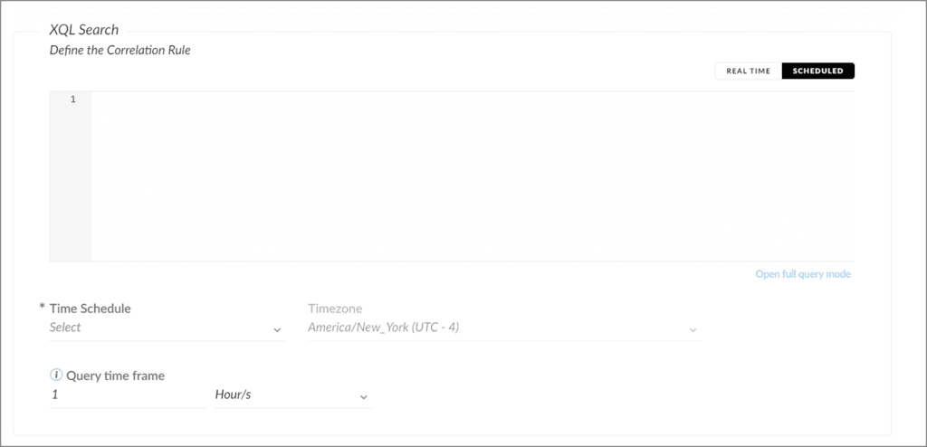

Contextualized Issues
- When a Correlation Rule detects a correlated event, it generates an issue that provides contextual information about the correlated events, including the contributing factors and the relationship between them. This context helps analysts understand the significance and potential impact of the event.
- 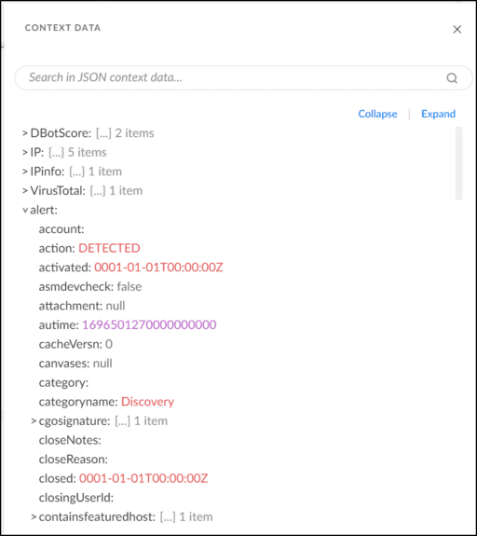

Issue Suppression
- Correlation Rules offer the option to suppress issues based on defined criteria. This feature allows you to configure rules to ignore certain events or event combinations for a specified duration. Issue suppression helps reduce noise and focus on actionable issues, enhancing the efficiency of threat analysis.
- 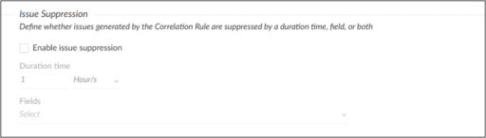

MITRE ATT&CK Mapping
- Correlation Rules can be associated with MITRE ATT&CK tactics and techniques. This mapping enables you to align your correlation rules with the MITRE ATT&CK framework, which provides a standardized taxonomy of adversary behaviors. By aligning with MITRE ATT&CK, you can gain a better understanding of the potential adversary techniques and tactics behind the correlated events.
- 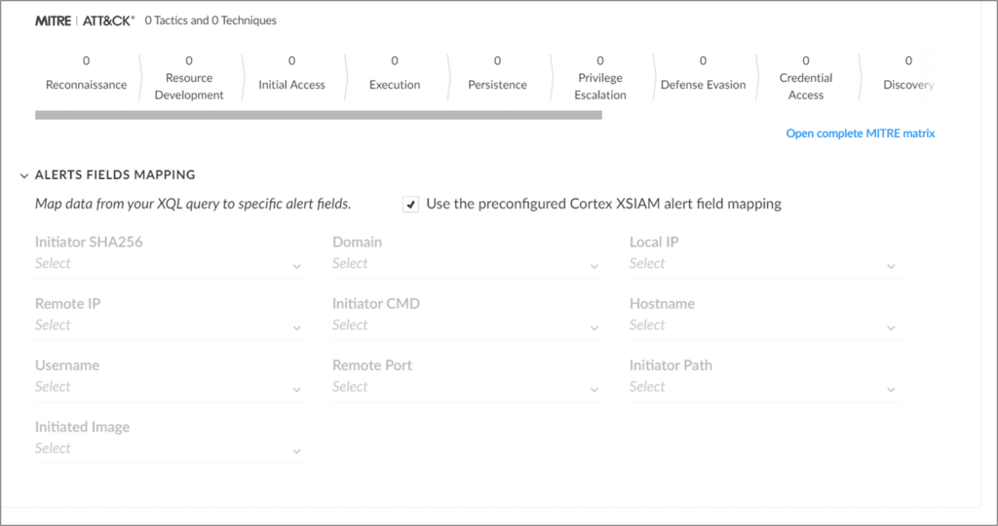

Cortex

Analytics

This lesson describes how analytics is used in identifying detected threats.

Analytics and Cortex
Cortex Analytics, or analytics within Cortex, involves the use of data, advanced algorithms, and machine learning techniques to proactively detect, analyze, and respond to security threats and anomalies in a network environment.

What Are Analytics?
Analytics, within the context of enterprise security, is a powerful approach that enables organizations to detect, analyze, and respond to threats effectively. It serves as the vigilant guardian of digital assets, continuously monitoring network activities and providing insights that help safeguard against a multitude of cyber threats.
At its core, enterprise security analytics leverages data and sophisticated algorithms to uncover anomalies, deviations, and patterns that may indicate potential security breaches or malicious activities within a network. This proactive approach is essential because cyber threats are constantly evolving and becoming more sophisticated, requiring advanced tools and techniques to stay one step ahead.

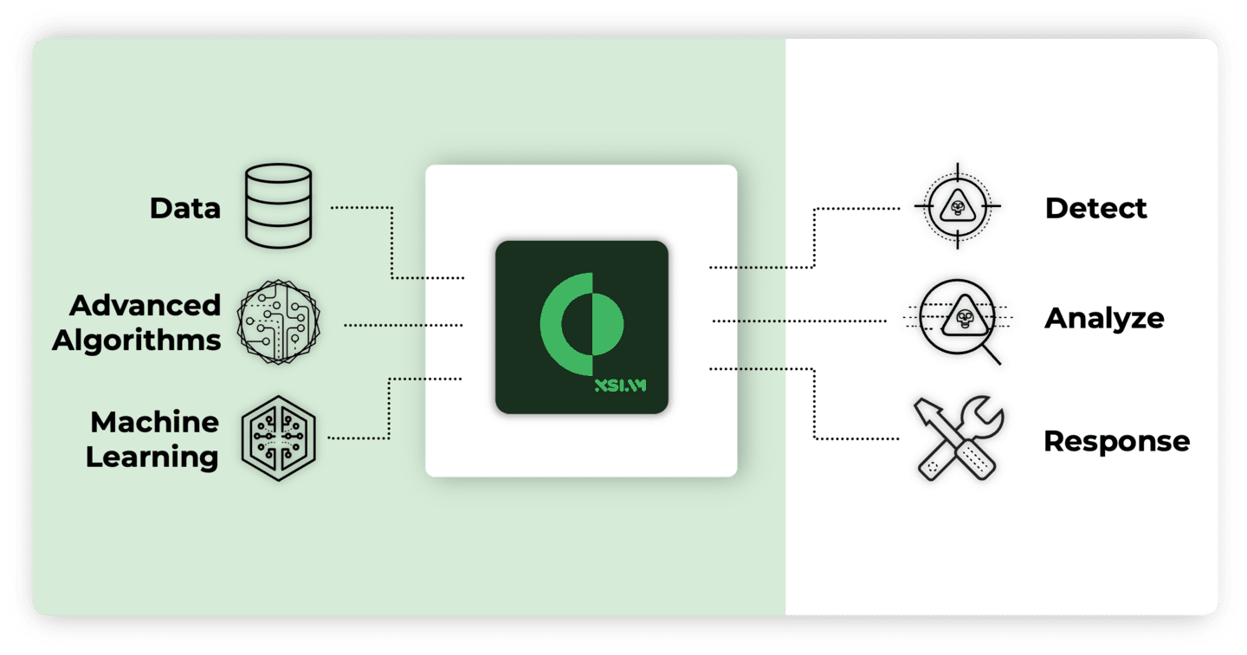

Cortex Analytics Features
Cortex Analytics is applied in network security to continuously monitor network activities and identify deviations from normal behavior, thereby enhancing the overall security posture. This approach encompasses a wide range of functionalities such as recognizing known threats, detecting suspicious behaviors, and providing security professionals with actionable intelligence. It plays a pivotal role in implementing a defense-in-depth strategy, securing networks across multiple layers from the perimeter to the core. Cortex Analytics includes the following features:
- 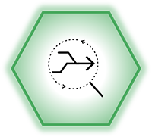
- Defense-in-Depth Strategy
- Analytics plays a vital role in a comprehensive defense-in-depth strategy, ensuring that networks are protected through up-to-date software and hardware, including patching vulnerabilities.
- 
- Intrusion Detection and Response
- Analytics is used to detect and respond to intruders who manage to penetrate network defenses, enabling quick evaluation, isolation, and removal of potential threats.
- 
- Cortex Platform
- The Cortex Platform is a powerful tool for efficient and automated abnormal activity detection on a network. It provides detailed information to aid in rapid threat assessment and mitigation.
- 
- Analytics Engine
- The Cortex Platform utilizes its Analytics Engine to analyze data from various sources, including logs from network sensors, to establish activity baselines and identify abnormal behavior.
- 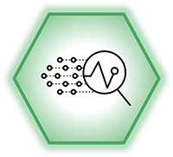
- Profile Creation
- The Analytics Engine creates profiles for endpoints and users within the network, categorizing them into peer group profiles, temporal profiles, and entity classification profiles. This contextual information is vital for detecting threats.
- 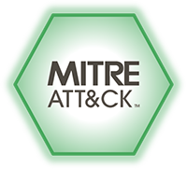
- MITRE ATT&CK Tactics Coverage
- Analytics can detect a range of attack tactics, including execution, persistence, discovery, lateral movement, command and control, and exfiltration, following MITRE ATT&CK knowledge base guidelines.

Course Summary
Now that you've completed this course, you should be able to:

- Identify the role of indicators of compromise (IOCs) and behavioral indicators of compromise (BIOCs) in threat detection
- Create and manage Correlation Rules
- Describe the capabilities and benefits of using Correlation Rules
- Differentiate between IOCs and BIOCs
- Describe the importance of network security analytics
- Explain how issues are generated
- Describe the features and functionalities of Cortex in enhancing threat detection and response

